10.86: a) The rings and the rod exert forces on each other, but there is no net force or torque on the system, and so the angular momentum will be constant. As the rings slide toward the ends, the moment of inertia changes, and the final angular velocity is given by Eq.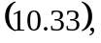
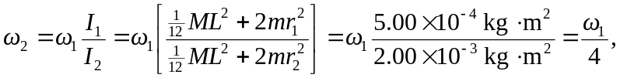
ans so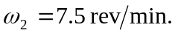Note that conversion from rev/min to rad/s is not necessary.
b) The forces and torques that the rings and the rod exert on each other will vanish, but the common angular velocity will be the same, 7.5 rev/min.

